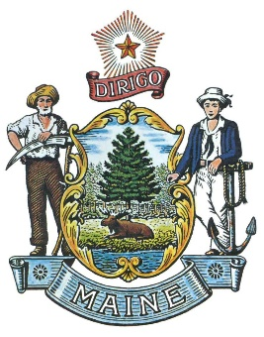
State of Maine LOSAP
LOSAP Board of Directors Meeting Minutes
January 14, 2019

Attendees: Bill Gillespie, Fred Brewer, Stephan Bunker, Jeff Brackett and Bill Hussey

Guests: Duane Bickford (Unappointed Board Member) Dan Brooks
The meeting was called to order by Bill Gillespie at 10:03

Minutes: Stephan Bunker motion to approve Jeff Brackett seconded. All approved.

RFP Discussion – Bill G responded to the RFP’s and withdrew the RFP. The goal is to get the parties (Penflex and VFIS) to the February meeting to discuss the information necessary to accomplish our goals to expedite the RFP process. Chad has confirmed that he can be at the meeting to help move the process along. Penflex and VFIS were concerned with the ability to get funding for the program.

Website – Working with Informe to develop the website. All member Bio’s are complete and we have signed the contract to develop the website. We are waiting on the URL approval from the CIO’s office. The goal is to have it operational in about a month.

Dan Brooks brought up discussions he has had with the chiefs at the commission meeting. Discussions have been around LOSAP and the fact that counties like York are still unaware of what we are trying to accomplish. Facebook has been a good source of outreach but has been somewhat limited. The goal is to have Penflex or VFIS do the outreach to each of the departments. Bill H is going to western Maine Chiefs meeting tonight. Jeff suggested inserting information into the monthly news letter for the Federation.

Hall of flags is February 7th at 8:30 (till 11) and legislative breakfast is the 14^{th at} 7:00 (till 9:30) need to be well attended with dress uniform. Touch base with your local legislators to let them know you are attending to get them LR 308 is the current placeholder for the program that Erin Herbig has submitted for our funding. The Contribution was arrived at 4,000 participants with $600 contributions. MMA will have information about the bill as it is presented. They will likely be able to get information sent out to municipalities. Stephan has suggested using the Manager of communications to get information into the Maine Townsman/Legislative summary and other MMA publications. Steve will contact MMA to start getting information out to the municipalities.

Facebook page currently has 429 likes. We need to develop a status update letter to go out to different municipalities and firefighters.

Next meeting is February 11^{th at MMA}.
Bill Hussey Motion to adjourn at 10:54, Bill Gillespie Seconded, all in Favor.

Respectively Submitted
Frederick Brewer

Future Meetings March 11th, April 8th, May 13th and June 10th

