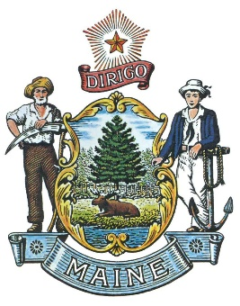
State of Maine LOSAP
LOSAP Board of Directors Meeting Minutes
March 11, 2019

Attendees: Bill Gillespie, Fred Brewer, Jeff Brackett and Bill Hussey

Guests: Marshall King (Unappointed Board Member)

The meeting was called to order by Bill Gillespie at 10:01

Minutes: Bill Hussey motion to approve Bill Gillespie seconded. All approved.

LD 1014 is currently presented to the Criminal Justice Public Safety Committee on the 22nd. The goal coming out of committee with unanimous support before going to appropriations.

Both RFP’s have been submitted as of 3/8/19. The goal is to have the proposals submitted on April 15th.

Joan will possibly join us in June after she retires to be Secretary.

Marshall King and Duane Bickford’s information has been resubmitted to the Governors office for approval.

The state website to review the bill is: Maine.gov/legislature/committee to view the information as the bill goes through the process.

Website – Working with Informe to develop the website. We have been setup with the federal government and need to get the server information and the website will be operational.

Facebook page currently has 435 likes.

Next meeting is April 8th at MMA.
Bill Hussey Motion to adjourn at 11:09, Jeff Bracket Seconded, all in Favor.

Respectively Submitted
Frederick Brewer

Future Meetings May 13th and June 10th

